Solution Design for Rental Car System

Jidong Li

July 27, 2020

Version 1.0.0

Contents
1. System Description 2
2. Functions Description 2
3. DB Design 2
4. Functions Design 2
5. DB tables 4

System Description
This is a rental car booking API service for customers to reserve a car for a period of time.

Functions Description
The system has following functions
- Rental cars by RentalOrderReq order.
- Back cars by RentalOrderReq order.
- Add inventory to the car.
- View car inventory.

DB Design
There are to storage system, the car storage and the borrower storage. The car storage save the car inventory information. The borrower storage save the status of lent cars and borrower.

Functions Design
- Rental cars by RentalOrderReq order.
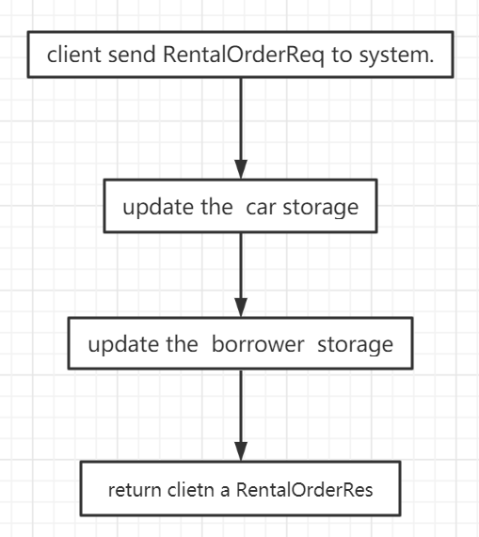
- Back cars by RentalOrderReq order.
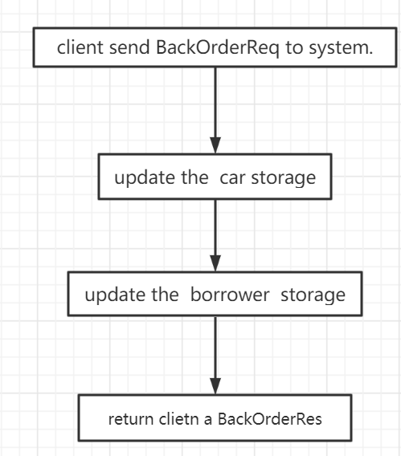
- Add inventory to the car.
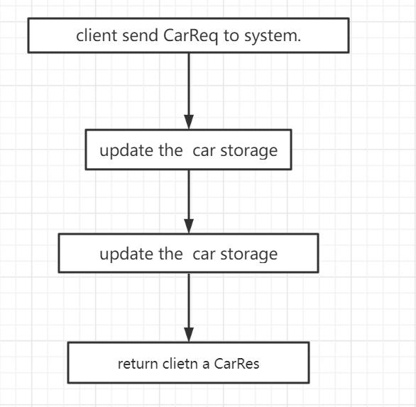
- View car inventory.
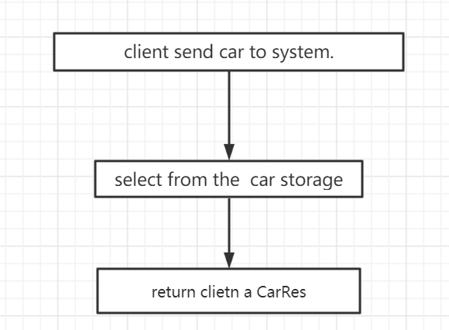

DB tables
See the API documentation for details.

